Lab 5

# Minifloat arithmetic

Recall from the arithmetic tutorial our minifloat format:

The first bit is the sign bit, the next 4 bits are the exponent (with a bias of 7), and the remaining 3 bits are in the form 1.mmm

Start with the same example from the board yesterday:

X = 0 1001 010

Y = 0 0111 110

$$X={(-1)}^{0}*1.010*2^{(1001-0111)}$$

Where the leading 1 on the exponent, the 2 and the 0111 are just all the standard, 0111 is the bias (7)

So what is X in base 10? 0b101 = 5

## What is Y in Decimal?

|  |
| --- |
| 1.110 x20 is in the notes yesterday  So that’s 1.75 |

## X*Y

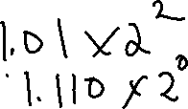

X = 0 1001 010



Y = 0 0111 110



$$X*Y=1.01*2^{2}*1.110*2^{0}$$

$$=1.01*1.110*2^{2+0}$$

$$=10.0011*2^{2}$$

$$=1.00011*2^{3}$$

Lastly we add 7 to the bias (3+7 = 10 = 0b1010), drop all bits at the end.



$$=0 1010 000$$

Though notice that *more* correctly we might want to round up that trailing 1

$$=0 1010 001$$

## X+Y

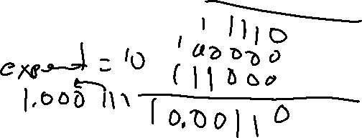

X = 0 1001 010

Y = 0 0111 110  
  
Convert your answer back to base 10 to see how close to correct it is

**Steps: Shift one to the base of the other (there are actually rules about which one you should shift, but for our purposes it doesn’t matter), then add, then shift to a 1.xxx format.**

|  |
| --- |
| $$X=1.01*2^{2}=101$$ $$101+1.110=110.110$$ $$110.110=1.10110{*2}^{2}$$ So in Binary that is (Add bias, drop the trailing bits) $$0 1001 101$$ With rounding = 0 1001 110  Back to base 10, that is 110.1 = 6.5, so we’ve lost 0.25 that just can’t be represented. |

## X-Y

**Steps: Same as addition, only, uh.. subtraction.**

$$101-1.110=011.01$$

That line might require a bit of explanation

101.000

-1.110

To do that you keep borrowing from the left (as needed).

You might need a guide on binary subtraction for this:

<http://www.exploringbinary.com/binary-subtraction/>

I tried to find a nice way to write it up, but it didn’t work as well as their guide

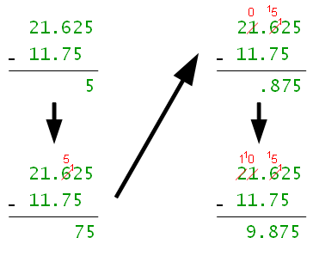 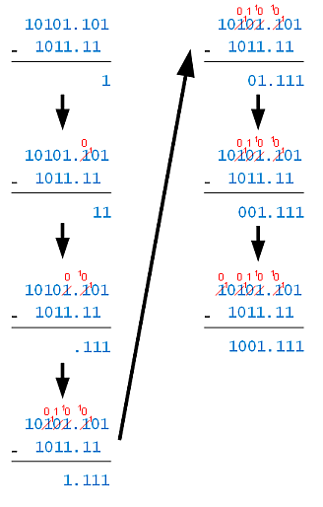

That is 1.101 * 2^1

Binary: 0 1000 101 **(We checked this a lot is should be right finally)**

## X/Y

X = 0 1001 010

Y = 0 0111 110

Steps: (Reverse of multiplication basically) X/Y = (Xf/Yf)*2(Xe-Ye)

|  |
| --- |
| Note that this is the same as 10100/111, so, for sake of sanity it might be easier to do that calculation $$=10.110110110….*2^{0}$$ $$=1.011*2^{1}$$ Into binary, sign bit is 1, bias is 0111 (7) |

X/Y = 0 1000 011

If we convert that to decimal, we get 2.75. The correct answer is 2.86 (roughly) so we’re pretty close.

# And 4 More Sample Problems

A= 1 0101 101 B = 0 0011 001

## Binary to Decimal

|  |
| --- |
| $$A=-1.101*2^{-2}=-0.40625$$ $$B=1.001*2^{-4}=0.0703125$$ |

## A+B

|  |
| --- |
| Students could just ignore the bias in the exponents $$A=-1.101*2^{-2}$$ $$B=1.001*2^{-4}$$ Shift to the same base $$B=0.01001*2^{-2}$$ Add (-110100+1001 = -101011) $$A+B= -1.01011*2^{-2}$$ Back to binary 1 0101 01**1 (the last 1 is rounding)** |

Back to binary 1 0101 010

## A-B

|  |
| --- |
| $$A=-1.101*2^{-2}$$ $$B=0.01001*2^{-2}$$ $$A-B=-1.11101*2^{-2}$$ Back to binary = 1 0101 111 |

Back to binary = 1 0101 111

## A*B

|  |
| --- |
| $$A*B=Af*Bf*2^{Ae+Be}$$ $$-1.101*1.001*2^{-2+(-4)}$$ $$=-1.110101*2^{-6}$$ Back to binary 1 0001 110 |

Back to binary 1 0001 110  
  
Note with this question, if the exponent on A or B was 2 lower (say -4, -4) then the resulting exponent would be -8, add the bias… and you can’t represent -1 as an exponent so the problem wouldn’t have a valid solution.

## A/B

|  |
| --- |
| $$A/B=Af/Bf*2^{Ae-Be}$$ $$-1.101/1.001*2^{-2-(-4)}$$ Remember that 1.101/1.001 is the same as 1101/1001  That gets you a repeating fraction result of $$-1.0111000*2^{2}$$ Back to binary that is  1 1001 011 Except, notice the rounding – so 1 1001 100 is more correct |

In binary 1 1001 100 note: the last 3 digits are rounded from 011